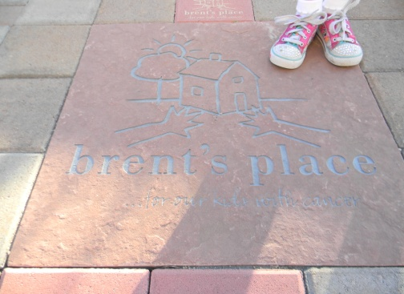
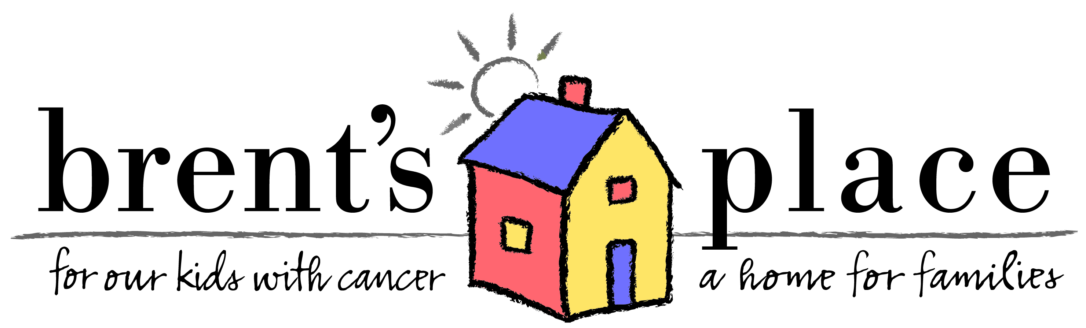
Walk of Hope
In some mythical places, the streets are paved with gold. But here at Brent’s Place, our paths are paved with memories, reminding us of the long roads many of our families took to get here.
Please consider the purchase of a customized brick for our Walk of Hope, a special place of reflection and celebration where our kids with cancer and their families can while away quiet sun filled afternoons. Each brick can be inscribed with a personal message, or a tribute to a loved one or special event.

*Walk of Hope pavers are dedicated at our annual Open House in December. All orders must be received by Friday, October 14th, 2022.
All pavers are engraved bricks available in two different sizes.
_____ # of 4”X 8” bricks with 3 lines of copy -$100 each (18 characters (including spaces) per line with both upper case and lower case letters)

_____ # of 8”X 8” bricks with 6 lines of copy -$500 each (18 characters (including spaces) per line with both upper and lower case or logo or image)
* Please note, spaces count as 1 character.
Line 1:
Line 2:
Line 3:

Ordered by:
_____________________________________________________________________________________
*Name
_____________________________________________________________________________________
*Email address *Home Phone
_____________________________________________________________________________________
*Address *City *State *Zip
______Enclosed is my check payable to Brent’s Place
______Please charge my credit card - Circle one: MC Visa American Express Discover
*Card #_____________________________________*Exp Date________________*Sec code_________
*Name on the card___________________________*Signature__________________________________
*denotes required fields
Please Send Notification To: _____________________________________________________________________________
Email: _______________________________________________________________________________________________

